THE PRISON BREAK CONNECTION

Game Design Document

By

Anuj Patwari

K1840581

Table of Contents

[Section I – Overview 4](#_Toc30951861)

[1.1. ID card 4](#_Toc30951862)

[1.2. High Concept 4](#_Toc30951863)

[1.3. Story 4](#_Toc30951864)

[1.4. Gameplay in a Nutshell 4](#_Toc30951865)

[1.5. Genre 5](#_Toc30951866)

[1.6. Target Audience 5](#_Toc30951867)

[1.7. Characters 5](#_Toc30951868)

[1.7.1. Lewis Huber 5](#_Toc30951869)

[1.7.2. Daisy Huber 5](#_Toc30951870)

[1.7.3. Carlos Mendez 6](#_Toc30951871)

[Section II – Gameplay 6](#_Toc30951872)

[2.1. Objective 6](#_Toc30951873)

[2.2. Core Mechanics 6](#_Toc30951874)

[2.2.1. Quick Time Events (QTE) 6](#_Toc30951875)

[2.2.2. Stealth 7](#_Toc30951876)

[2.2.3. Conversations 7](#_Toc30951877)

[2.2.4. Special Abilities 7](#_Toc30951878)

[2.3. Important Gameplay Sequences 7](#_Toc30951879)

[2.3.1. Car Chases 7](#_Toc30951880)

[2.3.2. Police Chase 8](#_Toc30951881)

[2.3.3. Ventilation Climbing 8](#_Toc30951882)

[2.4. Controls 8](#_Toc30951883)

[2.4.1. Sony PlayStation – Dualshock Controllers 8](#_Toc30951884)

[2.4.2. Microsoft XBOX Controls 9](#_Toc30951885)

[2.4.3. Nintendo Switch – Joycon Controls 9](#_Toc30951886)

[2.4.4. PC Keyboard and Mouse Controls 9](#_Toc30951887)

[2.5. Game World 10](#_Toc30951888)

[2.5.1. Carlos Mendez’s Mansion 10](#_Toc30951889)

[2.5.2. Prison 10](#_Toc30951890)

[2.5.3. Woods 11](#_Toc30951891)

[2.5.4. Warehouse 11](#_Toc30951892)

[2.6. Game Experience 11](#_Toc30951893)

[2.7. Enemies 12](#_Toc30951894)

[Section III – Multiplayer & Bonus Content 12](#_Toc30951895)

[3.1. Multiplayer 12](#_Toc30951896)

[3.2. Bonus Content 12](#_Toc30951897)

[3.2.1. DLC Story 12](#_Toc30951898)

[Section IV – Marketing & Monetization 12](#_Toc30951899)

[4.1. Pre-release 12](#_Toc30951900)

[4.1.1. Game Publishers 12](#_Toc30951901)

[4.1.2. YouTubers and Twitch Streamers 13](#_Toc30951902)

[4.1.3. Game Conventions and Conferences 13](#_Toc30951903)

[4.1.4. Pre-Purchases 13](#_Toc30951904)

[4.2. Editions 13](#_Toc30951905)

[4.2.1. Base Edition 13](#_Toc30951906)

[4.2.2. Deluxe Edition 13](#_Toc30951907)

[4.2.3. Ultimate Edition 13](#_Toc30951908)

[References 14](#_Toc30951909)

# Section I – Overview

## D:\Work\Kingston University\Term 2\Game Design\Game Design Document\Images\Pegi 16.jpgID card

Name – The Prison Break Connection

Genre – First Person, Stealth, Co-op

Platform – PC, PS4, PS3, XBOX One, XBOX 360

Target Audience – 16+ Years

## High Concept

The Prison Break Connection is a first person, co-op stealth game where the players have to escape prison, find evidence to prove their innocence and clear their name off from the criminal records.

## Story

***\*Please go through the Story document for the full details story sequence.\****

The players play as Lewis and Daisy (husband and wife) who have been framed by Carlos Mendez and wrongly arrested for something they did not do. Both the players are kept in different blocks of the prison for interrogation. The cops leave each of the interrogation rooms which the players take advantage of and escape.

After each of them leave their respective interrogation rooms, they both knock out a police officer, steal his clothes and act as police officers themselves now. Before doing anything else, both the players need to find each other. After they are re-united, they must find a way to escape from prison and then find evidence against Carlos Mendez and prove their innocence.

## Gameplay in a Nutshell

Most of the game takes place in a small prison where the two players are impersonating police officers. Many sequences through the game require the players to do quick time events. References to how these quick time events will look and feel are all mentioned through the Story document. The main inspiration for how the Quick Time Events (QTE) are supposed to feel is from the new Marvel Spiderman game. This video should give an idea of how the QTEs will take place in The Prison Break Connection - <https://www.youtube.com/watch?v=wfBiGDcdA9M>

During regular play phase, the players have to make sure they do not stay in front of police officers for too long otherwise it may lead to suspicion and their identification *(Reference -* [*https://www.youtube.com/watch?v=jLoowk\_7cXc*](https://www.youtube.com/watch?v=jLoowk_7cXc) *[Watch first 15 seconds]).* This leads to the players always being aware of their surroundings and being careful with every action they take. If the players are identified, the game is immediately lost.

There are multiple varying chase sequences also that take place through the game. References for each of them are mentioned in the story document for where they are relevant.

## Genre

This game is categorized as a Stealth game because the players are meant to escape from prison without being identified. Being identified by multiple police officers could make it impossible for them to escape.

The first person camera view was chosen because of the ability that Daisy holds – to make marks on Lewis’ body. *More about this in the character descriptions.*



## Target Audience

This game has violence and bad language. A target audience of 16+ years would be suitable for this game. Going for a higher PEGI rating is not required since this game would not involve any amount of sexual content and even the violence and bad language aren’t of extreme measure.

## Characters

### Lewis Huber



Lewis Huber is a bald, middle aged man who has a well-built body. He is no ordinary man. He has a special ability to turn into a mist-like thing for a brief few seconds which enables him to get through small and tight spaces as long as the opening wasn’t too far off. Once he turns back into normal form, he cannot immediately use his power again to transform into the mist since it takes up a good amount of his energy and he needs to gain his energy back before he can convert again.

### Daisy Huber

Daisy is a middle-aged, long blonde haired, average-built lady. She has the special ability to read Lewis’ mind and can also make small temporary marks on his body. So often in situations, when they cannot directly talk to each other, they use these powers to communicate with each other. For example, if Lewis wanted to ask Daisy if she’s fine, he’d just have to think “Daisy are you fine?” and then Daisy would just make a mark on his right arm indicating a “yes” or a mark on his left arm indicating a “no”.

### Carlos Mendez



Carlos Mendez is a middle-aged man with a stubble beard, well-groomed hair and an average-built body. He is a very rich and powerful man in the city. Most people do not know that he makes most of his money through illegal activities like extortion, selling drugs, human trafficking, etc.

# Section II – Gameplay

## 2.1. Objective

The main objective of the game is for the players to escape from prison by being stealthy and not exposing themselves. A few breaks in this objective can be found through the story to provide the players with a different experience from the regular flow and get some fast chase sequences in.

## 2.2. Core Mechanics

### 2.2.1. Quick Time Events (QTE)

This game has a lot of quick time events. Quick time events justify decisions and actions taken quickly and in an intuitive way and since this is a prison escape, realistically there are always going to be situations where the person in question would have to take decisions quickly and intuitively.

The quick time events in this game would be very similar to the ones found in Marvel’s Spiderman (2018). As mentioned earlier, this video *(*[*https://www.youtube.com/watch?v=wfBiGDcdA9M*](https://www.youtube.com/watch?v=wfBiGDcdA9M)*)* should give an idea of the kind of quick time events that take place, in terms of how the players need to click the buttons at the right time.

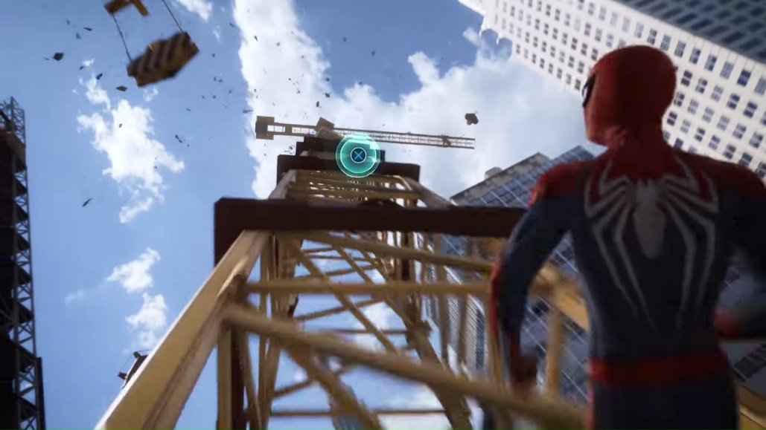

*If there are certain situations with their own different kind of QTE, they are mentioned in the story flow alongside the sequence where they occur.*

### 2.2.2. Stealth

This game has heavy emphasis on stealth while also being in plain sight. The characters must remain normal and not act suspiciously (fast walk or run in front of others when no emergency in the prison is announced) in front of the other cops. They must also not stand in front of other cops for way too long otherwise it may result in them recognizing that their ID card and their face do not match.

The players must try not to engage in conversations for too long and if anyone initiates any conversations, they must try to finish the conversations quickly to avoid being recognized.

### 2.2.3. Conversations

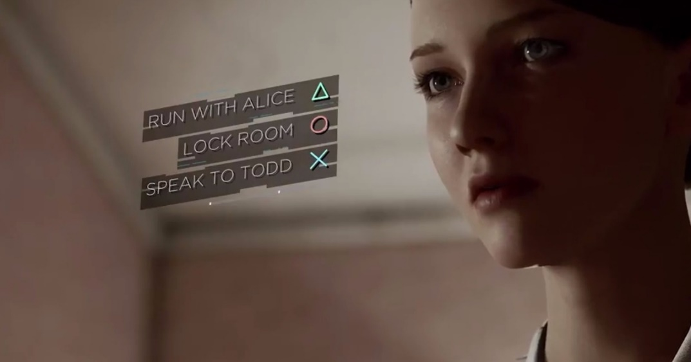At various points of the story, the players will be pulled into conversations with other people either by force or by their own choice. The players will have to make quick conversations with these people to avoid being recognized. The conversations in the game will happen like in the game, Detroit Become Human *(Reference -* [*https://youtu.be/xVEPpwqQh5k?t=150*](https://youtu.be/xVEPpwqQh5k?t=150) *[Min 2:30 to Min 6:42])*. Choices will be put in front of the player in each conversation where he/she must choose the best option that he/she thinks will end the conversation quickly.

### 2.2.4. Special Abilities

The special abilities that Lewis (transforming into mist) and Daisy (Reading Lewis’ mind and making temporary marks on his body) hold will be coming into use at many situations through the course of the game. To simulate Daisy’s ability to read Lewis’ mind, the player who plays Lewis will have a constant open mic and everything he/she says will be heard by Daisy and hence creating the “mind reading” feeling. Daisy’s player will not be having any mic access until the two players are together in the same room.

There is a break to this mechanic by the players using voice chat clients like Discord or TeamSpeak, hence there shall be a prompt at the beginning of the game for the players to not use any such clients to enjoy the game in the best way it is meant to be enjoyed.

## 2.3. Important Gameplay Sequences

### 2.3.1. Car Chases

There are two car chase sequences in this game. Both following a different way of doing a chase sequence. The first one (while escaping from prison) is more of a escaping while not trying to kill anyone or indulge in combat.

The second chase sequence (while escaping from Carlos Mendez’s warehouse) has more of combat where Lewis is made to jump from car to car to take down Carlos’ men while Daisy drives the car trying to avoid all the hurdles in her way.

### 2.3.2. Police Chase

The first playing sequence of the game happens with a police chase at Carlos Mendez’s mansion. Lewis and Daisy try to escape from the cops. The sequence is supposed to look and feel something like this - [*https://www.youtube.com/watch?v=yf-sMV9gZvc&feature=youtu.be&t=188*](https://www.youtube.com/watch?v=yf-sMV9gZvc&feature=youtu.be&t=188) *[Min 3:08 onwards].*

### D:\Work\Kingston University\Term 2\KU_Term2_GameDesign\Game Design Document\Images\Wall climb.jpg2.3.3. Ventilation Climbing

When Lewis and Daisy get into the ventilation duct from the security room, they eventually come out in a narrow vertical room. They have to climb this room to get to the opening which is at quite a height. They have to put both their backs together, interlock their hands and climb the wall *(*[*https://www.youtube.com/watch?v=cRp2V6NttRY*](https://www.youtube.com/watch?v=cRp2V6NttRY) *Make sure you mute your audio, it’s pretty loud).* Every step, they have to click the right button (based on what comes on screen) in order to climb successfully. If one person goes too high and the other fails to stay up to speed, it will result in both of them losing grip and falling.

## 2.4. Controls

The game will be best experienced when playing with a controller, but PC players may use a keyboard and mouse too if they cannot use a controller.

The way Daisy’s player makes the small temporary marks on Lewis’ body is by holding down her special ability button and then pressing the left or right arrow to say a no or a yes.

### 2.4.1. Sony PlayStation – Dualshock Controllers

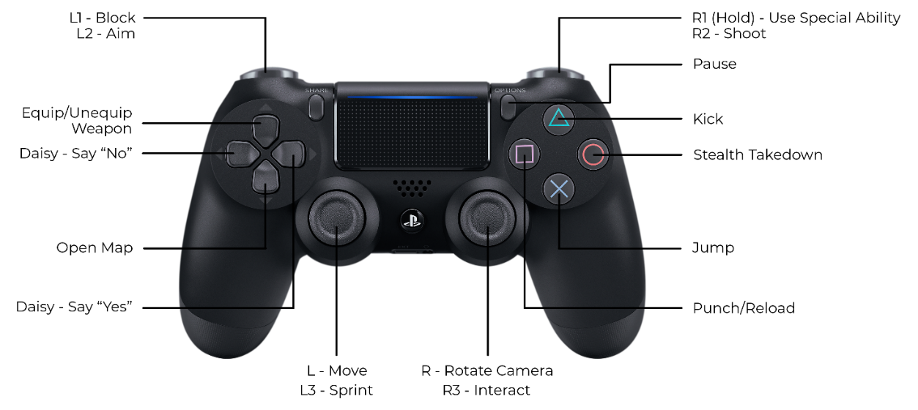

### 2.4.2. Microsoft XBOX Controls

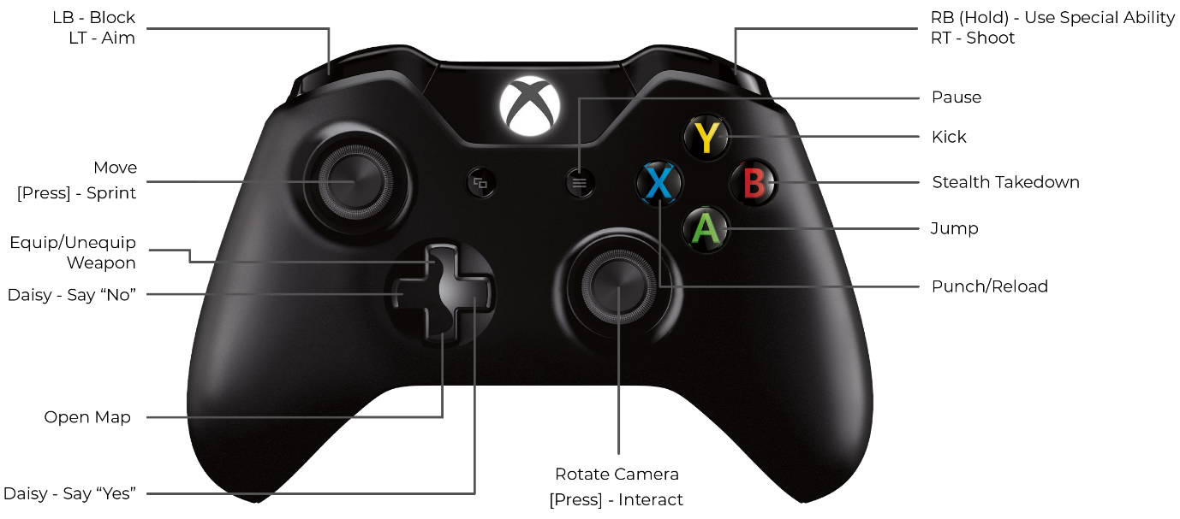

### 2.4.3. Nintendo Switch – Joycon Controls

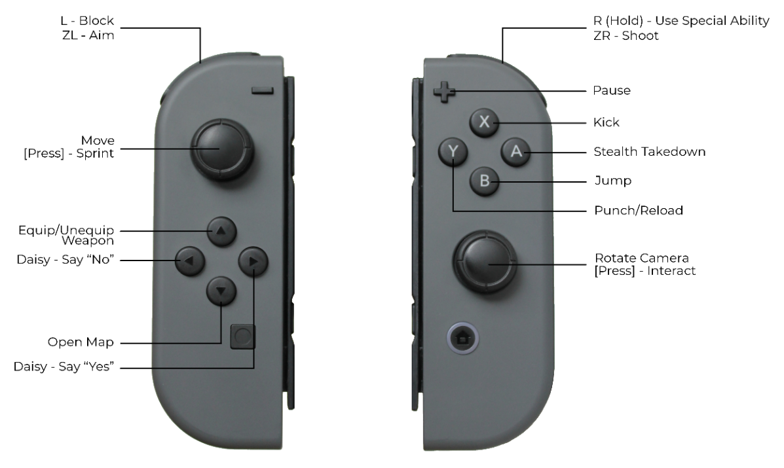

### 2.4.4. PC Keyboard and Mouse Controls

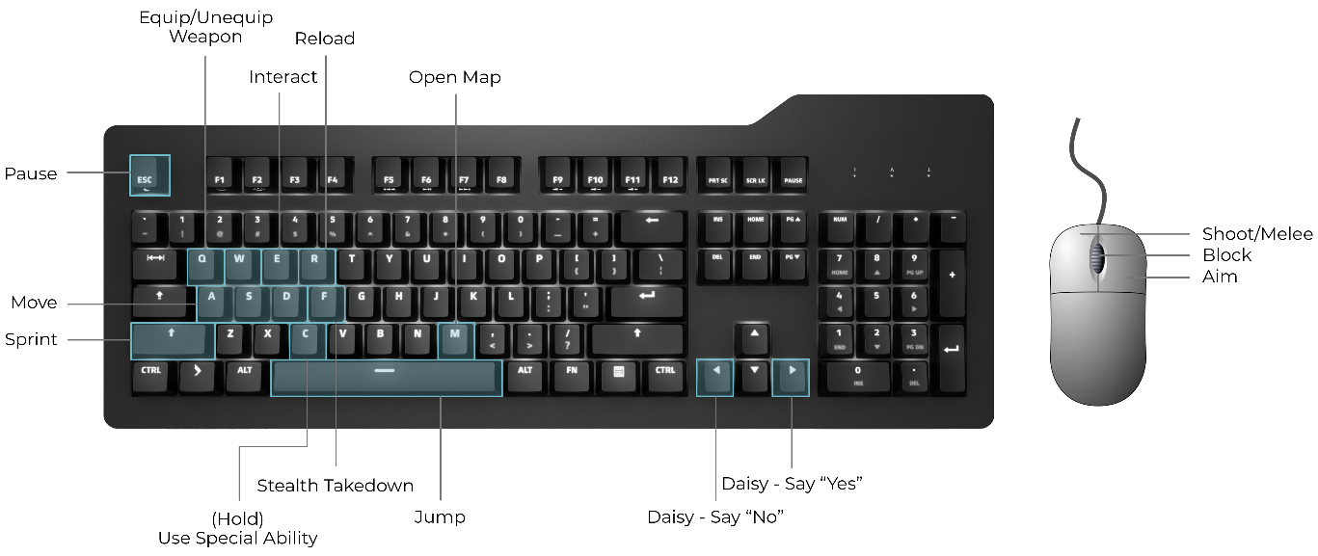

## 2.5. Game World

### 2.5.1. Carlos Mendez’s Mansion

The game starts in Carlos Mendez’s mansion where the players get arrested. A huge chase sequence is supposed to take place in this setting so a fairly large mansion is required. Reference - <https://www.nbcdfw.com/news/local/look-inside-the-cedar-hill-mansion-perched-high-above-north-texas/136260/>

The mansion in the link above should give a clear idea of the kind of mansion size and structure required. The mansion has many expensive artefacts, paintings and furniture spread all over. There are also quite a few people in the mansion who are either Carlos’ relatives or the workers who help maintain his mansion.



### 2.5.2. Prison

A majority of the game takes place in the prison where Lewis and Daisy are taken after being arrested from Carlos’ mansion. This is a fairly small prison in comparison to other prisons. It does not hold many prisoners hence it does not have too many police officers stationed here. The prison is populated by tables, chairs, police officers, vending machines (visitor’s room), potted plants, wall clocks, tools (workshop), prison cells, computers (staff office), etc.

The image below shows a very huge prison. For this game, the prison building will be like one of the “X” shaped buildings along with a tower in the centre at the intersection.



### 2.5.3. Woods

The surrounding area around the prison is very woody. It’s like a small forest at the other end of which is a bridge that leads to the main land where the city is located. In this forest area, there are a few cut trees, a weathered axe, an old well, small animals, birds and a small pond.



### 2.5.4. Warehouse

After laying low for a few weeks, Lewis and Daisy are determined to clear their name off and hence go looking for evidence that would prove their innocence and hopefully get Carlos Mendez caught. The head over to his “Warehouse” where there are drugs being manufactured by children that Carlos smuggled into the city.



## 2.6. Game Experience

This being a stealth game, the overall experience through most of the game should be of being very concentrated and always be on the lookout that no one has spotted you. There are a few sequences where the players are involved in no stealth whatsoever and this is because bringing in breaks into the flow by introducing some high paced moments makes the game more fun and unpredictable.

## 2.7. Enemies

As such, everyone around the players is an enemy, but none of them are enemies until they have identified the players as escaped prisoners. At such situations they are just like mere passers-by on a road. But there are a few characters that the players have to take down because of the structure of the story.

# Section III – Multiplayer & Bonus Content

## 3.1. Multiplayer

The game is a co-op game. Hence both players are to be given a balanced amount of emphasis. No player is more important than the other. This is the main philosophy to be followed when constructing various situations and sequences through the game.

The game can be played as both, an online multiplayer game or a local multiplayer game. If one of the players interested in playing the game has a copy of the game, the second person does not need to purchase the game in order to play with his/her friend. This practice brings a certain amount of reachability for the audience. If we force for two copies to be purchased, we’d lose a lot of our potential customers. Also, if someone willing to play the game has a copy but doesn’t have someone to play with, he/she can match up with someone online to play the game.

## 3.2. Bonus Content

As a bonus content for the game, there will be a DLC available at launch which gives the players access to an expansion for the story. The story of this expansion takes place a few weeks after Carlos Mendez has been arrested and taken into prison.

This DLC is purchasable separately for an additional £10 over the base game. The base game is required to play this DLC.

### 3.2.1. DLC Story

Carlos’ men have been keeping a close watch on Lewis and Daisy and have gathered information on their special abilities. They go into Lewis and Daisy’s house and blackmail them saying that they know about their abilities and would make the evidence public. They know that if the world came to know about their abilities, it would cause chaos for them and also could lead to them being under constant surveillance by the government. It could also lead to them being detained because these abilities can be seen as potential danger.

Carlos’ men tell Lewis and Daisy to help Carlos escape from prison. If they are not successful in this job, their abilities would be made public.

# Section IV – Marketing & Monetization

## 4.1. Pre-release

### 4.1.1. Game Publishers

Various game publishers like EA Originals, No More Robots, Devolver Digital, Team17, etc. shall be contacted by pitching the game to them with proper trailers, PowerPoint presentations, demo gameplay builds, etc. in an attempt to convince them to publish the game. Upon evaluating all the available options and what each publisher is offering, a decision shall be made and one of the publishers shall be chosen to go ahead with.

A publisher is very important to this project because a good publisher could bring in a lot of attention and could also automatically attract a good player base to purchase the game. The publisher can also market the game through all their pre-established social media platforms and could also sponsor for the game to be set up at various events where people could try it.

### 4.1.2. YouTubers and Twitch Streamers

About 3 weeks before release, the game shall be sent to most Game Streamers on Twitch and YouTube. We shall start with sending it to the streamers with not a huge fan base, but a respectable amount because this being a new IP, not many big streamers will be necessarily interested in it. Once the game starts getting some popularity through these not-so-big streamers, then it shall be sent out to the big ones who are now intrigued to play it.

This would gain a lot of popularity for the game and attract a lot of audience towards what the game is and bring the name out to the public.

### 4.1.3. Game Conventions and Conferences

The game would be showcased at various game conferences such as E3, GDC, Develop Brighton, etc. for the thousands of people who turn up at these events. They could try out the game at these events and this could help market the game by word of mouth.

Showcasing the game at these events will also grab the attention of a large number of people. Many games that have been showcased at such events have had great success in automatically attracting a lot of people into buying the game or pre-purchasing it.

### 4.1.4. Pre-Purchases

The game will be open for pre-purchases six months before release with trailers, small gameplay footage, screenshots, etc. on the many platform store pages. Pre-purchases would be a good way to get funding for the final six months which are generally crunch periods of the development process.

## 4.2. Editions

The game is meant to not be too expensive since it is from an indie developer and people don’t really like paying so much for indie games. Also, lower costs attract more people to purchase the game.

### 4.2.1. Base Edition

The base edition of the game will cost £20. It will only include the base game.

### 4.2.2. Deluxe Edition

The deluxe edition will retail at £25. This edition of the game will include the base game and some special sound tracks that are not available in the base version.

### 4.2.3. Ultimate Edition

The ultimate edition of the game will be sold at £33. This edition will include the base game, the special sound tracks and also the bonus DLC (mentioned above) where Lewis and Daisy now need to help Carlos escape from prison.

The price is set at £33 to give the customer some discount over buying the deluxe edition and then the DLC separately which would have cost £35.

# References

Abs4Fun (2019) Marvel Spider-Man All Quick Time Events!!! Available at: <https://www.youtube.com/watch?v=wfBiGDcdA9M> (Accessed: 16 November 2019).

Bayon Fighters (2019) TOM CRUISE JACK REACHER PRISON ESCAPE SCENE HD. Available at: <https://www.youtube.com/watch?v=kY1d-u-XDDI> (Accessed: 6 January 2020).

brentina14 (2007) Kevin and Aaron wall climb. Available at: <https://www.youtube.com/watch?v=cRp2V6NttRY> (Accessed: 29 November 2019).

calloftreyarch (2016) Uncharted 4: A Thief's End - Best Chase In Gaming History. Available at: <https://www.youtube.com/watch?v=2MEpYiS2aOI> (Accessed: 23 December 2019).

ColumbiaPicturesPhils (2017) BABY DRIVER - 6-Minute Opening Clip. Available at: <https://www.youtube.com/watch?v=6XMuUVw7TOM> (Accessed: 9 January 2020).

Entertainment Access (2018) All Spider-People Introduction Scene - SPIDER-MAN: INTO THE SPIDER-VERSE (2018) Movie Clip. Available at: <https://www.youtube.com/watch?v=kAqcxq7kH5s> (Accessed: 2 January 2020).

Frosty Games (2018) HEAVY RAIN How to pick Lock. Available at: <https://www.youtube.com/watch?v=WyTATZQLEgY> (Accessed: 4 January 2020).

Fusion Gaming (2018) A Way Out - Prison Fight Scene. Available at: <https://www.youtube.com/watch?v=yz1pPCCekxk> (Accessed: 5 January 2020).

Gamer's Little Playground (2018) A WAY OUT AMAZING CHASE SCENE. Available at: <https://www.youtube.com/watch?v=yf-sMV9gZvc> (Accessed: 18 December 2019).

HaqiX Helix (2015) Assassin's Creed Syndicate Hide the Body in Nigel in for the Chop Mission. Available at: <https://www.youtube.com/watch?v=jLoowk_7cXc> (Accessed: 12 December 2019).

NBC (2019) See Inside the $9.8M Mansion Perched on the Highest Point of North Texas. Available at: <https://www.nbcdfw.com/news/local/look-inside-the-cedar-hill-mansion-perched-high-above-north-texas/136260/> (Accessed: 2 January 2020).

VGS - Video Game Sophistry (2018) Detroit: Become Human - Connor's Awkward Lunch with Hank (All Options). Available at: <https://www.youtube.com/watch?v=xVEPpwqQh5k> (Accessed: 18 November 2019).

END OF DOCUMENT